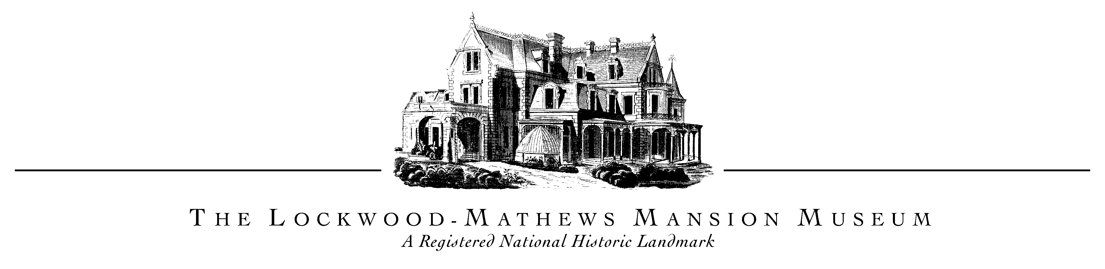

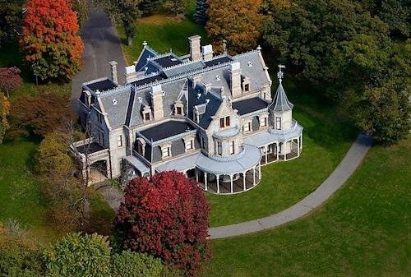

The Lockwood-Mathews Mansion Museum, a *National Historic Landmark* since 1971, is an ideal venue for elegant weddings, private celebrations, and corporate events. Viewed by millions as the set of several Hollywood movies and featured on the A&E television series, America’s Castles, the Mansion offers a unique and magnificently restored first-floor. This historic property has a splendid Rotunda with soaring forty-two foot ceilings and four beautifully furnished period rooms reflecting the elegance and grandeur of Victorian décor. The Lockwood-Mathews Mansion Museum is an ideal setting for a truly memorable event!

* Weddings
* Birthdays
* Anniversaries
* Holiday Parties
* Board Retreats
* Corporate Events